CENWP-OD-B 10 September 2010

MEMORANDUM FOR THE RECORD

SUBJECT: Dead chinook at Bonneville’s Adult Fish Facility (AFF).

On 10 September at approximately 1015, CRITFC researchers notified BON Fisheries of a chinook mortality in the AFF. The chinook had difficulty recovering from anesthesia, and rolled when fish were released from the brail pool. CRITFC was unable to recover it. CRITFC had previously decreased the number of fish present in the brail pool at one time. The carcass was disposed of down Valve 15 drain in the AFF. The following information was collected:

- Species – Chinook female
- Origin – unclipped
- Length – 95.2cm
- Water temperature – 18.5°C
- Marks and tags - 3D9.1C2D3F17A2
- Marks and Injuries found on carcass – partial descaling on left side
- Cause and Time of Death – 1015
- Future and Preventative Measures – N/A

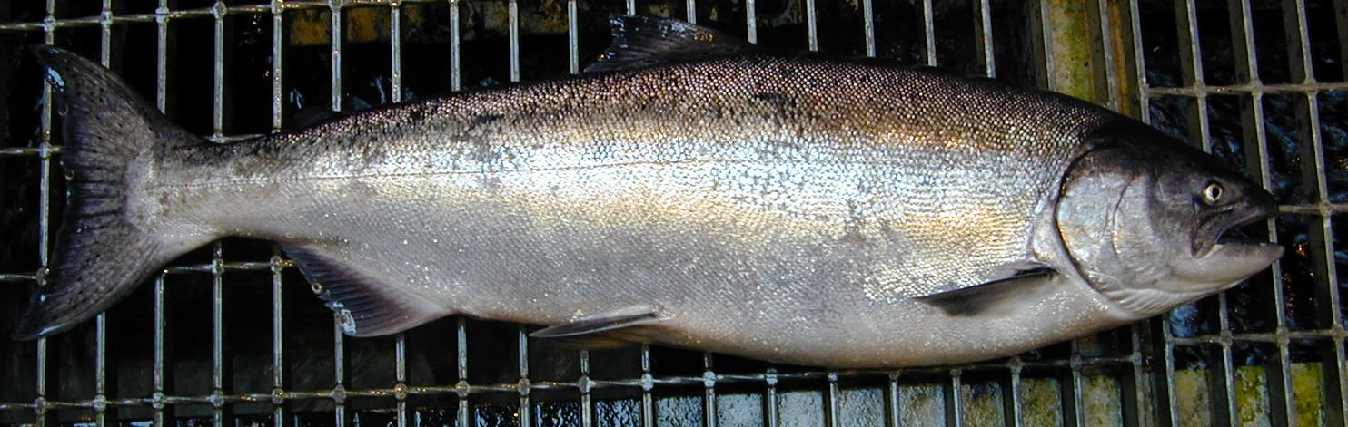

Bonneville Fisheries

